BARNES FAMILY CHIROPRACTIC CLINIC
4302 DEL PRADO BLVD
CAPE CORAL, FL 33904

APPLICATION FOR TREATMENT

DATE:

NAME: NICKNAME:
ADDRESS:

CITY: STATE: ZIP: -

SS NO.: - - AGE: DOB: - - SEX:

MARITAL STATUS: Single Married Divorced Widow Other

NAME OF SPOUSE: AGE OF CHILDREN

PHONE #:(H) - (W) - (Cell) -

OCCUPATION: EMPLOYER:

STUDENT? FULL TIME PART TIME NAME OF SCHOOL

WHO REFERRED YOU TO THIS CLINIC?_____YELLOW PAGES ______FRIEND ______FAMILY
_____INTERNET _____ DOCTOR_____ OTHER

WHO IS RESPONIBLE FOR YOUR BILL? ______SELF ______HEALTH INSURANCE
____ EMPLOYER ____AUTO INSURANCE ____WORKERS COMP ____OTHER

HEALTH INSURANCE INFO: SECONDARY INSURANCE INFO:
NAME OF INS: __________________________ NAME OF INS:________________________
POLICY #: ______________________________ POLICY #: ____________________________
GROUP #: ______________________________ GROUP #: ____________________________

IS THIS INJURY AUTO RELATED?_______ OR JOB RELATED?_______

AUTO ACCIDENT INSURANCE INFO: WORKER COMPENSATION INFO:
NAME OF INS.________________________ NAME OF INS._________________________
POLICY #:____________________________ GROUP #_____________________________
CLAIM#:_____________________________ POLICY #_____________________________

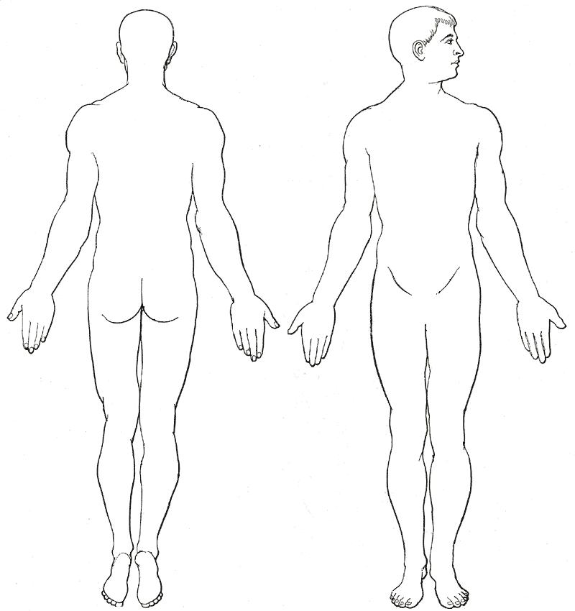
PLEASE MARK THE EXACT LOCATION OF YOUR PAIN:

DESCRIBE YOUR MAJOR COMPLAINTS:

__________________________________________________

(TURN PAPER OVER AND COMPLETE OTHER SIDE)

CHECK SYMPTOMS YOU HAVE NOTICED PAGE 2

__ Headache __ Irritability __ Shortness of breath __ Face Flushed
__ Neck Pain __ Chest Pain __ Fatigue __ Diarrhea
__ Sleep Problems __ Pins & Needles in arms __ Depression __ Fainting
__ Back Pain __ Pins & Needles in legs __ Light bothers eyes __ Loss of smell
__ Nervousness __ Numbness in fingers __ Loss of memory __ Loss of taste
__ Tension __ Numbness in toes __ Ringing in ears __ Balance
__ Feet Cold __ Hands Cold __ Upset stomach __ Constipated
__ Cold sweats __ Fever __ Head seems heavy
__Balance changes

Symptoms other than above:________________________________________________________

How did this condition develop?_____________________________________________________
_______________________________________________________________________________

When were you first aware of this problem?_____________________________________________
_______________________________________________________________________________

Have you ever had this or a similar problem before? if yes, when, where, What were the results:___
_________________________________________________________________________________

Has your condition been getting better? Worse or staying the same?:_________________________
________________________________________________________________________________

What makes your condition worse:____________________________________________________

How has this affected your Home L ife:________________________________________________

Occupation:_____________________________________________________________________

Recreation:______________________________________________________________________

Rest & Sleep:_____________________________________________________________________

Have you lost any days from work due to this condition? If yes, dates:_________________________

Any accidents or falls that might have caused your problem:________________________________

DATE:___________________________________________________________________________

Have you had any back or spinal surgery I should be aware of:______________________________

What previous surgery has been done?_________________________________________________

Is there a possibility of pregnancy at this time?:YES_________________ No:_______

Do you have a pacemaker?:YES________________ No:_________

Are you taking ____Nerve pills ____Pain killers ___ Muscle relaxers ___Tranquilizers
____Insulin ____Birth control ___ Others

Do you have high or low blood pressure? _____ Any heart problems ___Aneurysms
Phlebitis____ HIV____

Chiropractors consulted in the past, Name:______________________________________________

Fees are payable at time of x-rays, examination, and treatment are received unless other arrangements
are made in advance. Records remain the property of this clinic.

SIGNATURE:_______________________________________________DATE:___________________

