Barnes Family Chiropractic
4302 Del Prado Blvd., Cape Coral, FL, 33904

Patient Intake Sheet – Auto

Auto Insurance Information:
Auto Insurance Company__________________________________________________
Policy # __________________________________ Claim # _____________________
Insured’s Name_________________________________ Relation__________________
Date of Accident ___/___/_____
By signing below I understand and agree, it is my sole responsibility as patient to notify the physician’s office of any and all changes in my health insurance plan/policy. I understand failure to do so in a timely manner may result in the charges being my sole responsibility. I also authorize release of any and all personal health information necessary to process any claim(s) to this office. I have read and understand all the above.

Signature_____________________________________ Date ___ / ___ / ______
We will need a copy of your auto insurance card

Attorney Information:
Law firm Name___________________________________________________________
Contact Name____________________________________________________________
Phone Number (____) ____ - __________ Address_____________________________
_______________________________________________________________________

Auto Accident History:
1.What type of vehicle were you in during your accident? Make_______________ Model ___________ Year _______ Car SUV Truck 4-door 2-door Other________________

2. Brief description of the other vehicle(s) involved in the accident.__________________
________________________________________________________________________

3. (a)What position were you in the vehicle? Driver Passenger-front Passenger-rear(driver side) Passenger- rear(middle) Passenger-rear(passenger side) (b)Seat belted? Shoulder/lap Lap only None Other:______________________

4. The vehicle you were in was stopped traveling ____mph.
Your vehicle was traveling North South East West.

The accident occurred on__________________________ (street name) and _____________________ (street)________________ (city) ____(state)

5. Point of impact on the vehicle you were traveling in: Front bumper Rear bumper
Driver Side: front quarter panel driver door passenger door rear door
rear quarter panel Other_____________________________
Passenger Side: front quarter panel passenger door passenger rear door
rear quarter panel Other____________________________

6. Any additional accident details:___________________________________________________________
______________________________________________________________________________________________________________________________________________________________________________

Estimated damage to vehicle $___________________

If you were NOT treated at the scene of the accident OR at any other health care facility, please SKIP to question 13.

Treatment History:
7. Were you treated at the scene Yes No
If yes, by whom? (EMS, Police department, Fire department, etc…)________________________
What injury were you treated for? ___________________________________________________

8. Did you travel via EMS to receive medical treatment? Yes No
If No, how did you travel to seek treatment?___________________________________________
Which hospital or care center did you arrive at?________________________________________
Were you kept for an overnight stay at the facility? Yes No

9. Did you receive any of the following imaging studies at the hospital:
X-rays Ct Scan MRI
What part(s) of the body was the imaging done ________________________________________

10. Please list ANY and ALL injuries that you sustained and treatment/tests that were done at the hospital.________________________________________________________________________________ _____________________________________________________________________________________________________________________________________________________________________________
11. Did you seek treatment for any injuries from this accident from any other healthcare provider(s)?
Yes No
If so who? And for what?_________________________________________________________________
______________________________________________________________________________________
______________________________________________________________________________________

12. What prescription medication did you receive for injuries from your accident?_____________________
_______________________________________________________________________________________
Barnes Family Chiropractic • 4302 Del Prado Blvd. • Cape Coral, Fl • 33904

Patient Name:_________________________________

Medical History:
13. Have you ever been involved in any previous accidents or other injuries? (Please list all and when)____
______________________________________________________________________________________

14. Have you ever been treated for any previous neck or back injuries? Yes No
If so, what?_____________________________________________________________________________
Name of previous treating physician(s)_______________________________________________________

15. Please list any over-the-counter and prescription medication you are currently taking. Please list the reason for use.
Drug Name Reason for use
_____________________ ___________________
_____________________ ___________________
_____________________ ___________________
_____________________ ___________________
_____________________ ___________________
_____________________ ___________________
_____________________ ___________________
_____________________ ___________________

16. Please list any health conditions you have.__________________________________________________
_______________________________________________________________________________________

17. Please list any previous surgeries you have had.______________________________________________
_______________________________________________________________________________________
_______________________________________________________________________________________

18. Please list any previous hospitalizations.____________________________________________________
_______________________________________________________________________________________

19. Please list any significant family health history.______________________________________________
_______________________________________________________________________________________

Social History:
Number of children living with you?____________
Alcohol use: None Occasionally Socially Daily How much?__________________
Tobacco use: ____ packs per day for ____ number of years. When did you quit?______________
Recreational drug use:____________________________________________________________________

Barnes Family Chiropractic • 4302 Del Prado Blvd. • Cape Coral, Fl • 33904

Occupational History:
What is your occupation?__________________________________________________
What type of job duties do you do?__________________________________________
Have you lost any time off from work due to the accident? Yes No
If yes, how much? _______ hours or ________days
Have you returned to work? Yes No Full duty or restricted?______________

Present Complaints:
Please describe your complaints.(Use as many descriptive words as possible, i.e. burning, sharp, dull, pins and needles, numbness, constant, off and on. Include body location.) _______________________________________________________________________________________
____________________________________________________________________________________________________________________________________________________________________________________________________________________________________________________________________________________________________________________________________________________________

Please mark the location of your pain. Please check any or all symptoms you have:
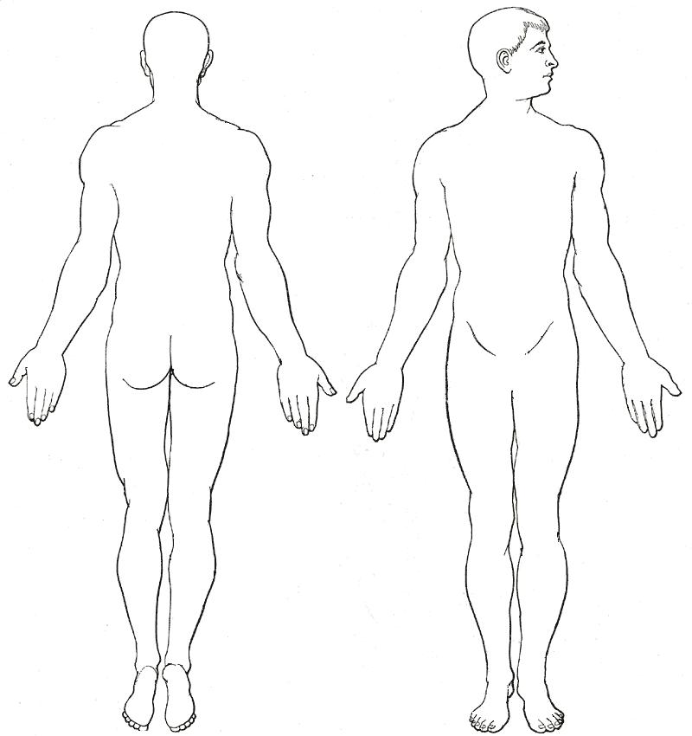
__Neck pain __Sleep problems
__Back pain __Nervousness
__Tension __Feet Cold
__Balance changes __Irritability
__Chest pain __Pins& Needles in arms
__Pins & Needles in legs __Numbness in fingers __Numbness in toes __Hands cold
__Fever __Shortness of Breath
__Fatigue __Depression
__Light bothers eyes __Loss of memory
__Ringing in ears __Upset stomach
__Head seems heavy __Face Flushed
__Diarrhea __Fainting
__Loss of smell __Loss of taste

Is there anything that makes your symptoms better?_____________________________________________
Is there anything that makes your symptoms worse?_____________________________________________
Are you experiencing headaches? ٱYes ٱNo How often?________________________________
Are there any daily living activities that are affected by your injuries? Yes No
If so, which activities?_____________________________________________________________________

Any additional comments you would like to make?______________________________________________
_______________________________________________________________________________________
_______________________________________________________________________________________

By signing below, I attest that the information given above is true to the best of my knowledge.

________________________________________________ ____/____/______
Signature Date
Barnes Family Chiropractic • 4302 Del Prado Blvd. • Cape Coral, Fl • 33904

